Standard Operating Procedure (SOP)
Document name: Anaphylaxis and emergency management
Document category: Vaccinations
Document heading: Section F - Vaccinations
Internal ID: IM05 / F05
Review Frequency: Every 2 years
Reviewed by: xx
Next Review: xx/xx/xxxx

Purpose

To optimally manage an incident of anaphylaxis or faint, and to help differentiate the two conditions.

Personnel

All pharmacist vaccinators and first aid-qualified staff.
All other staff must be aware of the risk of anaphylaxis and faints from vaccinations, know the warning signs, and know to watch patients after vaccination, and report untoward effects to the pharmacist vaccinator immediately.
Procedure

Signs and symptoms of anaphylaxis
- Vaccinators need to be able to distinguish the signs and symptoms of anaphylaxis and be able to differentiate anaphylaxis from fainting.
- There is no conservative management of anaphylaxis. Early administration of adrenaline is essential.
- Misdiagnosis of anaphylaxis or fainting may lead to inappropriate use or a delay in the administration of adrenaline.

 | Signs and symptoms | Severity
Early warning signs (within a few minutes) | Dizziness, perineal burning, warmth, pruritus, flushing, urticaria, nasal congestion, sneezing, lacrimation, angioedema | Mild to moderate
 | Angioedema, hoarseness (laryngeal oedema), dyspnoea, abdominal pain, vomiting, substernal pressure | Moderate to severe
Life-threatening symptoms (from soon after the injection up to 20 minutes after) | Bronchospasm, stridor, collapse, hypotension, dysrrhythmias | Severe
Adapted from the Immunisation Handbook 2020 (September 2020)
Immunisation stress-related response
- Immunisation stress-related response (ISRR) is a term use to cover a spectrum of responses to stress generated by immunisations.
- These responses vary from fainting and hyperventilation through to dissociative neurological symptoms, which include non-epileptic seizures.
- Note: not all symptoms occur, and sometimes symptoms on only one system can occur in anaphylaxis, potentially causing misdiagnosis. When a patient faints, consciousness is usually recovered within a minute or two.

Distinguishing anaphylaxis from a faint (vasovagal reaction)
 | Faint | Anaphylaxis
Onset | Usually before, at the time, or soon after the injection | Soon after the injection, but there may be a delay of up to 30 minutes
System
Skin | Pale, sweaty, cold and clammy | Red, raised and itchy rash; swollen eyes and face; generalised rash
Respiratory | Normal to deep breaths | Noisy breathing due to airways obstruction (wheeze or stridor); respiratory arrest
Cardiovascular | Bradycardia; transient hypotension | Tachycardia; hypotension; dysrhythmias; circulatory arrest
Gastrointestinal | Nausea/vomiting | Abdominal cramps
Neurological | Transient loss of consciousness; good response once supine/flat | Loss of consciousness; little response once supine/flat
Adapted from the Immunisation Handbook 2020 (September 2020)
Distinguishing a hypotonic-hyporesponsive episode from anaphylaxis
- A hypotonic-hyporesponsive episode is a shock-like state defined by the sudden onset of limpness (muscle hypotonia) and decreased responsiveness, with pallor or cyanosis in infants and children aged under 2 years after immunisation.
- A hypotonic-hyporesponsive episode can occur from 1 hour to 48 hours after immunisation, typically lasts less than 30 minutes, and resolves spontaneously.
- A hypotonic-hyporesponsive episode is a recognised serious reaction to immunisation and should be reported to CARM see SOP F06 Managing and reporting an adverse reaction.

Emergency equipment
- The pharmacy must have an emergency kit including telephone access in the same room as the vaccines are administered. One person in the pharmacy should be made responsible for maintaining the emergency kit. This should be documented, with an alternate person named in case the first person is away.
- The staff member responsible for maintaining the emergency kit is: [insert staff name]
- The alternative staff member responsible is: [insert staff name]

The emergency kit contains:
Adrenaline 1:1000 | At least 3 doses
Sterile syringes 1 mL | At least 3 syringes
Sterile needles 23 or 25 G x 25 mm, 22 G x 38 mm | At least 3 of each size
Cotton wool, gauze
Other emergency equipment required:
Adult and Paediatric bag valve mask resuscitator (eg, Ambu bag)
Cellphone or phone access

- See Appendix 2 Vaccines – Off site vaccinations checklist
- Print and laminate the signs and symptoms and management of anaphylaxis sheet for use in the pharmacy and take to off-site vaccinations.See Appendix 1 below: Vaccines – Signs and symptoms and management of anaphylaxis sheet
- Before commencing vaccination, the pharmacist vaccinator must ensure the emergency kit is readily available and contains in-date adrenaline, as well as syringes, needles and the directions for adrenaline use.
- All pharmacist vaccinators and first aid-qualified staff must know how to deliver the oxygen kept at the pharmacy. [delete if you do not choose to keep an oxygen cylinder]
- The pharmacist vaccinator must screen all patients for risk factors in the pre-vaccination checks.
- The pharmacist vaccinator must ensure all patients are advised of the risk of anaphylaxis and given written information that includes recognition of anaphylaxis and what to do.
- The time of vaccination should be recorded and patients are advised to stay in the pharmacy, in line-of-sight, for 20 minutes after their injection.
- Patients are encouraged to sit for the vaccination in case of fainting and to sit after the vaccination if feeling faint or dizzy.
- Ensure the oxygen regulator is open prior to vaccinating. Oxygen flow should be checked, but does not need to be flowing during vaccination. The regulator should be turned to the closed position 20 minutes after the last patient has been vaccinated. [delete if you do not choose to keep an oxygen cylinder]
- The emergency kit should be checked every 4 weeks for all supplies, and prior to vaccinating to ensure nothing is missing, expired or damaged, and ensuring the oxygen is working. [delete if you do not choose to keep an oxygen cylinder]
- Adrenaline must be protected from light and excessive heat. Replace if discoloured brown.
- If the emergency kit is used, it must be replenished as soon as possible. No vaccinations can occur if the kit is incomplete. Notify all vaccinators, and clearly highlight in a prominent place – eg, the vaccine fridge and/or vaccination folder - to ensure vaccinations do not occur until the emergency kit has been replenished.

Emergency management
Managing a faint
- If a patient is feeling faint or dizzy, or goes pale, ask them to sit or lie down. If the person has fainted, ensure someone remains with them while they lay down with their legs elevated. The patient should regain consciousness within 1-2 minutes.
- A faint may be more likely in people who are fasting, when they feel pain, are scared or see blood or a needle. A fall could cause a serious injury. Someone who seems particularly nervous or has gone without breakfast may be more likely to faint. Put them at ease, suggest having something to eat before the vaccination, and seat them during and after the vaccination. Draw up the vaccine out of their sight, and ask them to look away when administering it. If rapid recovery does not occur, consider possible causes other than a faint.

Managing anaphylaxis
- Assess – if unconscious, place in the recovery position and start basic life support (airway, breathing, circulation). If cardiorespiratory arrest occurs, administer CPR and life-support measures.
- Call for help – ambulance or doctor.
- Position patient safely – do not allow them to stand and never leave them alone.
- Administer adrenaline – Adrenaline dosage for 1:1000 formulation is 0.01mL/kg up to a maxiumum of 0.5mL/. If weight is unknown or under 10kg’s, use the following guidelines:
  - Age 2 – 4 years - 200mcg (0.2 mL)
  - Age 5 – 11 years - 300mcg (0.3 mL)
  - Age 12 years and over – 500 mcg (0.5 mL)
- The patient should respond to adrenaline within 1-2 minutes. If necessary, adrenaline can be repeated at 5-15 minute intervals to a maximum of three doses while waiting for assistance. Use alternate sites/limbs for additional doses.
- Be prepared to commence age appropriate CPR – If needed.
- Administer oxygen (if available) – use high-flow rates, eg, 15L/min where respiratory distress, stridor or wheeze occur.
- Record vital signs every 5-10 minutes. Clearly document all observations and interventions and send with the individual to hospital.
- Admit to hospital – all cases of anaphylaxis should be admitted to hospital for observation. Rebound anaphylaxis can occur 12-24 hours after the initial episode.
- All anaphylaxis reactions should be reported to CARM. Include the patients’ NHI numbers if possible for CARM.
See SOP F06 Managing and reporting an adverse reaction to a vaccination

Created by | Date
Approved by | Date

Appendix 1: ^{(ref 36)}
Signs and symptoms and management of anaphylaxis sheet*
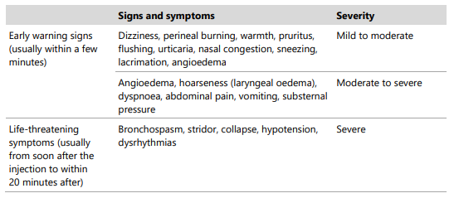
Distinguishing anaphylaxis from a faint*
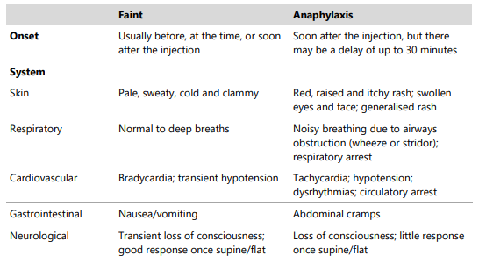
*Adapted from the Immunisation Handbook 2020

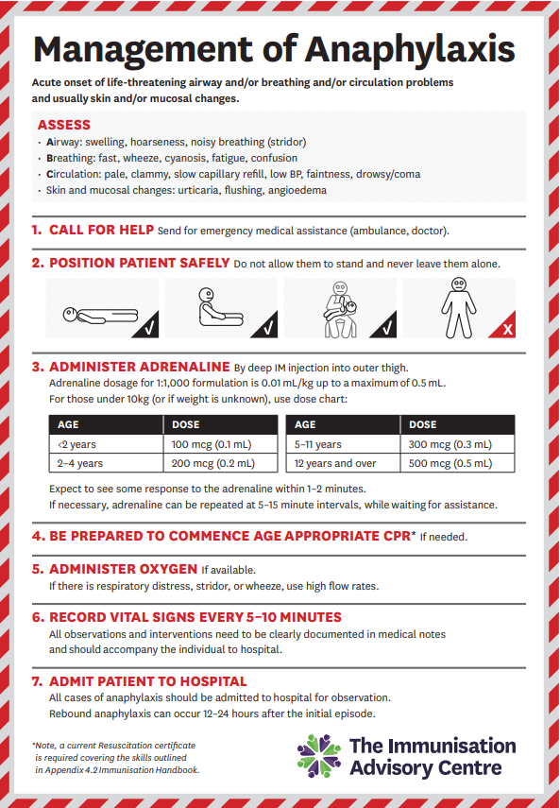
Appendix 2: Equipment Checklist for off-site vaccinations ^{(Ref. 39)}
Item | Quantity | Checked (Yes/No)
Emergency kit containing:
Adrenaline 1:1000 | At least 3 doses
Sterile syringes 1 mL | At least 3 syringes
Sterile needles 23 or 25 G x 25 mm, 22 G x 38 mm | At least 3 of each size
Cotton wool, gauze
Cellphone or phone access
Biohazard sharps container
Adult and Paediatric bag valve mask resuscitator (Ambu-bag)
Pen and paper for emergency use
Sterile 1 mL syringes
Sterile needles 23 or 25 G x 25 mm
Sterile needles 22 G x 38 mm
Cotton wool, gauze
Surgical tape or plasters
Chilly bin (NOT polystyrene)
Insulation for bin (between stock and ice)
Ice packs (warmed to remove frost)
Data logger with a probe, external display and alarm placed amongst vaccines
Vomit bowl or bag
Tissues
Disposable gloves
Hypochlorite (0.5%) bleach
Approved biohazard bag
Alcohol swabs
Hand sanitiser
Access to immunisation handbook
Pre-vaccination checklists, consent, info sheet
“Signs and symptoms and management of anaphylaxis” laminated sheet
Medical staff notified if being used for first aid
Second chilly bin with ice packs if necessary
Optional equipment:
Oxygen cylinder
Oxygen regulator (or flow meters)
Adult/Paediatric mask & tubing
OP airways size 3
OP airways size 4
Blood pressure monitor
Thermometer for patient temperature

* Initial each box to signify the presence of the required amount of stock suitable for use (ie, unexpired, undamaged, and/or unopened).
Vaccines stock taken:
Brand | Quantity taken & initials | Quantity returned & initials

Time vaccines removed from fridge: ____________
Time vaccines returned to fridge: ______________

Did the temperature deviate from 2-8°C? Yes / No (if yes explain, include temperature, time and action taken): _______________________________________________________________________
_______________________________________________________________________

Other comments: _______________________________________________________________________

Vaccinator Sign: _______________________
Name: _____________________
Date: ________________
NOTE: Keep all documentation associated with monitoring the temperature of the vaccines in chilly bins for 10 years, along with the rest of the cold chain documentation.

