|  |
| --- |
| **Standard Operating Procedure (SOP)**  **Document name:** Administration of vaccines in adults, adolescents, and children 3 years and up  **Document category:** Vaccinations  **Document heading:** Section F - Vaccinations  **Internal ID:** F02.4  **Review Frequency:** Every 2 years  **Reviewed by:** xx  **Next Review:** xx/xx/xxxx |
| **Purpose**  To ensure that vaccinations are administered safely and correctly by authorised vaccinators to the patient groups permissible by the vaccine classification.  **Personnel**  Vaccinators  **Pharmacy Quality Audit Requirements**   * *Are sales of medicines such as ECP, trimethoprim and the administration of vaccines made by an accredited pharmacist or vaccinator?*  1. *Is a record of supply kept? (eg, in the dispensary computer)?* 2. *Is the identity of the accredited pharmacist/vaccinator recorded?* 3. *Is the medicine labelled as if dispensed?* |

|  |  |
| --- | --- |
| **Procedure**  **Vaccinator Training and Assessments**   * A pharmacist vaccinator is a New Zealand registered pharmacist with a current Annual Practising Certificate who has completed the vaccinator training course and passed the clinical assessment. A Vaccinator is a person who has completed the relevant vaccinator training course(s) and passed the clinical assessment as prescribed by IMAC (see <https://www.immune.org.nz/health-professionals> ). * Following the completion of the initial vaccinator training course, each vaccinator must complete the vaccinator update course every two years. * Copies of all certifications for completion of the vaccinator training course, pharmacist vaccinator update course and clinical assessment for each pharmacist vaccinator needs to be kept at the pharmacy (including all previous certificates and assessments). * **Note:** Copies of the clinical assessment and certificates for every vaccinator training course and vaccinator update course must be retained to show proof that current status has been retained over the years. * These documents are kept [state where the pharmacy keeps this document]. * All pharmacist vaccinators must advise the Pharmaceutical Society when they have completed any vaccinator training or vaccinator update courses.   **First Aid Requirements**   * Vaccinators must undertake resuscitation training that includes the following resuscitation skills:   + Infant, children and adult CPR, including mouth to mouth, mouth-to-mask and the management of choking   + Administration of IM adrenaline for treatment of anaphylaxis   + Use of an automated external defibrillator   + One- and two-person bag valve mask ventilation and mouth-to-mask technique   + Resuscitation training updates required at least once every two years * When providing vaccination services, a minimum of two staff must be present, one being a pharmacist vaccinator and the other being at a minimum, a competent staff member who is able to call for emergency support and has a basic life support first aid certificate. * The second staff member does not have to be a pharmacist or a pharmacist vaccinator/vaccinator. * For non-pharmacist staff, basic life support first aid training should be refreshed every two years. * Copies of all first aid certificates must be kept at the pharmacy. * These are kept [state where the pharmacy keeps this document]. * Vaccinations can only be administered where the vaccinator is satisfied necessary first aid equipment is available. * First aid equipment must be checked four-weekly.   **General requirements for a vaccinator**   * Have read and understood the National Standards for Vaccine Storage and Transportation for Immunisation Providers 2017, the Dispensary Refrigerator Temperature Monitoring Record or Annual Cold Chain Management Guide and Record and the Cold Chain Management Policy [delete one]. * Have carefully read the relevant disease-specific chapter/s of the Immunisation Handbook. When a new Immunisation Handbook is released, re-read disease-specific chapters for vaccinations administered. * Pharmacist vaccinators or vaccinators can only administer vaccinations as permitted by vaccine classification or the Director General of Health or a Medical Officer of Health. * Be signed off on the pharmacy-specific vaccination SOPs (this must be documented). * Be familiar with the pre-vaccination checklist and consent forms for vaccinations given. * All vaccinations are given according to the manufacturer’s directions, the current Immunisation Handbook, instructions from the immunisation advisory centre (IMAC), and the appropriate pre-vaccination checklist and consent form. The Immunisation Handbook or IMAC information takes precedence over the datasheet if differences occur. If unsure, contact IMAC for advice (0800 466 863).   **Pre-vaccination considerations**   * The vaccinator should check if the patient is eligible for government-funded vaccinations. * The appropriate pre-vaccination checklist and consent form needs to be completed, including documenting informed consent. Parental consent is not required for adolescents aged 16 years or older. * The checklist and consent form need to be filed securely for 10 years. After three years, this may be retained in another form, eg, electronically. * The vaccinator should ensure the patient understands what the vaccine is for, how it is given, the possible side effects, and the risks of not being vaccinated. * The vaccinator must also ensure that the patient is aware of any specified time that the patient is required to wait after vaccination. Eg, the need to wait onsite for 20 minutes after vaccination or a different specified time as outlined by IMAC. Refer to Appendix 4 for appropriate post-vaccine observation times. * If the patient is eligible for government-funded vaccination, this option must be explained, including where it is available. The patient may still choose to pay to be vaccinated in the pharmacy, e.g., for timing reasons. Any costs involved should be disclosed to the patient(s) before vaccination. * Only vaccinate in a private and appropriate clinical setting. * Provide written and verbal information to the patient on their vaccination as per the pre-vaccination checklist, consent, and information document specific to the vaccine used. Include what to do if an adverse event occurs and advice on when to notify the vaccinator. * Give the patient a notification letter for their general practitioner, or send directly to their doctor, with their permission.   **Drawing up an injection from a vial**   * Clean the bench and allow to dry. * Wash your hands. * Only draw up the injection after obtaining informed consent to administer the vaccine. * Assemble a luer-lock sterile needle and syringe, eg, 22 G 25 mm. * Check the vial is the correct one. * Check the vial is within date. * Check the vial contents contain no foreign particles or discolouration. * If the vial label has a detachable part, remove this and apply to the documentation, if not, record the brand name, batch and expiry. * Flip the plastic lid off the vial without touching the rubber bung. * Shake the vial if required (this will be stated on pack or in the datasheet). * Draw up the entire volume into the syringe (or the quantity specified on the checklist and consent form). * Check for foreign particles. * Always change the needle before administration   *See SOP F07 Disposal of needles, syringes, and clinical waste*   * Discard the used needle and vial in the sharps bin. * Draw up shortly before administering the injection, out of sight of the patient (to reduce patient unease).   **Reconstituting a powder for injection**  Follow the instructions as for drawing up an injection (above) but add the following steps:   * Draw up the appropriate amount of diluent, adjust the quantity (after removing large air bubbles), and add the diluent to the vial of powder. * Mix the powder and diluent according to manufacturer’s directions. * Using a different entry point on the vial bung, use a needle and syringe to draw up the required quantity. Check the quantity after removing large air bubbles. * Discard the used vial in the sharps disposal bin. * Remember to change the needle for administration.   **Note:** In exceptional circumstances, the injection may not be administered immediately following draw up, eg, person faints before administration. In this case, label the syringe with name of injection, date and time. Store and use within manufacturer’s instructions (see datasheet) and best practice. Expiry may be just 20 minutes. Discard in the sharps bin if expired.  *See below, Appendix 1 Vaccines - Subcutaneous delivery*  *See below, Appendix 2 Vaccines - Intramuscular delivery and*  *Appendix 3 Vaccines - Appropriate needle size selection*  *See below, Appendix 4 Vaccines – determining appropriate patient observation times.*  **Administration of vaccines**   * Examine the stock before starting to administer a new injection. I.e., vaccine hasn’t frozen, no crystallisation present, vaccine hasn’t discoloured. * Check that the vaccine is the correct vaccine, and that the vaccine is within date. * Check the temperature recording chart for variations in temperature before using the vaccines. * Take appropriate action if the cold chain is not maintained. * Do not mix injections in the same syringe. * Alcohol wipes are not necessary pre-vaccination, unless the skin is dirty. If used, alcohol must completely dry on the skin before injecting the vaccine to maximise the sterilising effect,and reduce the risk of tracking alcohol into the muscle. * Alcohol may damage a live attenuated vaccine. * Wearing disposable gloves is optional. If worn, change between each patient. * Wash hands or use hand sanitiser (and allow to dry to be effective) before each vaccination. * Do not prime the needle, i.e., do not expel air, before administration. * The patient should be seated in case of a faint. * Seating the vaccinator is not mandatory, but can put the patient at ease and aid in correct siting of the injection. * Do not recap needles after vaccinating – this risks a needle stick injury. Discard immediately into a sharps container after use. * Wash hands or use hand sanitiser and allow to dry before and after each vaccination.   **Technique for the administration of a subcutaneous (SC) vaccination**   * A subcutaneous injection should be administered into healthy tissue that is away from bony prominences and free of large blood vessels or nerves, preferably in the upper arm overlying the deltoid muscle. * The subcutaneous tissue is a fatty layer between the dermis and the muscle.   **Needle size**   * The needle should be 25-26 gauge and 16 mm long. A longer needle may cause inadvertent IM injection. People with a thin layer of fat, eg, someone with anorexia or cachexia, or a very athletic, fit young man may need a shorter needle to avoid injecting into the muscle.   **Process**  1. Remove the patient’s non-dominant arm from the garment.  2. Gently pinch the skin over the deltoid muscle to raise the subcutaneous tissue.  3. Hold the syringe like a dart with your index finger and thumb.  4. Inject into arm at a 45° angle with a quick thrust.  5. After injecting all vaccine release the pinched tissue then remove the needle in a quick smooth motion at the same angle of insertion and immediately place into the sharps container. Do not take your eyes off the needle until it is in the sharps container, and do not recap.  6. Using cotton wool, apply slight pressure to the injection site to discourage bleeding. Apply a wound dressing.  **Technique for the administration of an intramuscular (IM) injection**   * **Note:** Only pharmacist vaccinators or vaccinators who have been assessed by the immunisation assessor as competent with IM vaccination administration may administer IM vaccines. * An IM injection should be administered in healthy, well-developed muscle, in a site as free as possible from the risk of local, neural, vascular and tissue injury. * Incorrect IM administration high into the deltoid muscle can cause serious shoulder injuries and reduced effectiveness of the vaccine. An IM injection at the junction of the middle and upper third of the lateral aspect of the arm may damage the nerve. Seating both the injector and patient may reduce the risk of injecting too high.   **Needle size:**   * A 23-25 gauge needle should be used. Most adolescents and adults require a 25 mm (1 inch) needle to effect deep IM deposition. In people under 60kg, a 16 mm needle may be needed. A 21-23G 38 mm (1.5 inch) needle may be required for a deltoid injection in an obese person. * **Note:** Careful use of a longer needle will cause less damage than a shorter needle   **Process**   * Remove the patient’s non-dominant arm from the garment * Find the acromion process * Find the lower deltoid attachment point (approximately the level of the axilla) * Draw an imaginary triangle pointing downwards from the acromion * Use the vaccinator’s non-dominant hand to hold the patient’s arm * Hold the syringe like a dart with your index finger and thumb * Inject into the centre of the imaginary triangle, or the point half way between the markers using a dart-like motion at a 90° angle with a quick thrust * The vaccine should be deposited at the bulkiest part of the muscle * After injecting all vaccine, remove the needle in a quick smooth motion at the same angle of insertion and immediately place into the sharps container. Do not take your eyes off the needle until it is in the sharps container, and do not recap * Using cotton wool, apply slight pressure to the injection site to discourage bleeding. Apply a wound dressing.   **Recording patient details into the Aotearoa Immunisation Register**   * For instructions on how to setup access to the Aotearoa Immunisation Register (AIR), *see appendix 112 Vaccinations – getting started* * All vaccines given by a pharmacist vaccinator are to be recorded on the AIR, where possible.   This SOP should be reviewed if the manufacturer’s directions change, a new edition Immunisation Handbook becomes available, or a new vaccination becomes available for pharmacists. | |
| **Created by** | **Date** |
| **Approved by** | **Date** |

**Appendix 1: Administration of a subcutaneous (SC) injection**

A subcutaneous injection should be administered into healthy tissue that is away from bony prominences and free of large blood vessels or nerves, preferably in the upper arm overlying the deltoid muscle.

The subcutaneous tissue is a fatty layer between the dermis and the muscle.

**Needle size**

The needle should be 25-26 gauge and 16 mm long. A longer needle may cause inadvertent IM injection. People with a thin layer of fat, e.g. someone with anorexia or cachexia, or a very athletic, fit young man may need a shorter needle to avoid injecting into the muscle.

**Process**

1. Remove the patient’s non-dominant arm from the garment.

2. Gently pinch the skin over the deltoid muscle to raise the subcutaneous tissue.

3. Hold the syringe like a dart with your index finger and thumb.

4. Inject into arm at a 45° angle with a quick thrust.

5. After injecting all vaccine release the pinched tissue then remove the needle in a quick smooth motion at the same angle of insertion and immediately place into the sharps container. Do not take your eyes off the needle until it is in the sharps container, and do not recap.

6. Using cotton wool, apply slight pressure to the injection site to discourage bleeding. Apply a wound dressing.

**Appendix 2: Administration of an intramuscular (IM) injection**

* **Note:** Only pharmacist vaccinators who have been assessed by the immunisation assessor as competent with IM vaccination administration may administer IM vaccines.
* An IM injection should be administered in healthy, well-developed muscle, in a site as free as possible from the risk of local, neural, vascular and tissue injury.
* Incorrect IM administration high into the deltoid muscle can cause serious shoulder injuries and reduced effectiveness of the vaccine. An IM injection at the junction of the middle and upper third of the lateral aspect of the arm may damage the nerve. Seating both the injector and patient may reduce the risk of injecting too high.

**Needle size:**

* A 23-25 gauge needle should be used. Most adolescents and adults require a 25 mm (1 inch) needle to effect deep IM deposition. In people under 60kg, a 16 mm needle may be needed. A 21-23G 38 mm (1.5 inch) needle may be required for a deltoid injection in an obese person.
* A Guide to appropriate Needle size can be found in Table 2.8 here: <https://www.health.govt.nz/our-work/immunisation-handbook-2020/2-processes-safe-immunisation> or see Appendix 3 included.
* **Note:** Careful use of a longer needle will cause less damage than a shorter needle

**Process**

1. Remove the patient’s non-dominant arm from the garment
2. Find the acromion process
3. Find the lower deltoid attachment point (approximately the level of the axilla)
4. Draw an imaginary triangle pointing downwards from the acromion
5. Use the vaccinator’s non-dominant hand to hold the patient’s arm
6. Hold the syringe like a dart with your index finger and thumb
7. Inject into the centre of the imaginary triangle, or the point halfway between the markers using a dart-like motion at a 90° angle with a quick thrust
8. The vaccine should be deposited at the bulkiest part of the muscle
9. After injecting all vaccine, remove the needle in a quick smooth motion at the same angle of insertion and immediately place into the sharps container. Do not take your eyes off the needle until it is in the sharps container, and do not recap
10. Using cotton wool, apply slight pressure to the injection site to discourage bleeding. Apply a wound dressing.

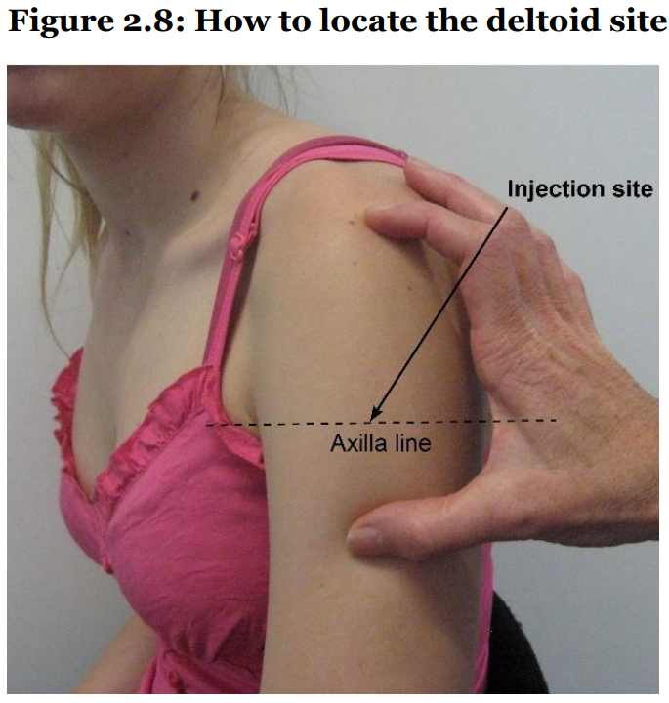

Diagram showing how to locate the deltoid site from the Ministry of Health’s Immunisation Handbook, 2020.

**Appendix 3:**

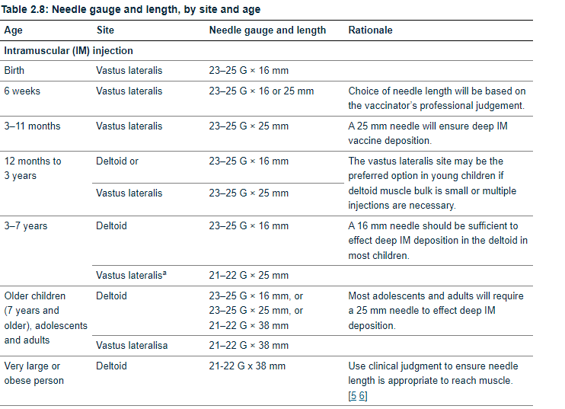

**Appendix 4:**

